SAA-C02 Summary
Full Notes link: link

Auth & Security

IAM
IAM User
- login to console – auth through Username+Password
- login to CLI/SDK – auth through Access Key of the IAM User
IAM Role
- role attached to a service to connect with other AWS Services

Compute & Servers

EC2
On demand – pay as u go pricing
Reserved – paid on a tenure basis
Spot intances – cheaper – buying based on availability
Concetpts:
Hyperthreading – optimizes a core into 2 vCPUs by making best use of execution units
Hibernating – when instance is Hibernated, all the state, running processes are saved to Root volume(EBS)
Ec2 user data – used to bootstrap the instances.
Ec2 placement groups:
- all the instances are Clustered in a rack
- instances are Partitioned from other instances in different racks (1AZ)
- Spread across MAZ

Load balancer
 | ALB(lyr7) | NLB(lyr4(Transaport layer)) | GWLB(lyr3(NW lyr))
Target: | forward traffic to application/microservice | To Server/pod | To include a firewall and forward to it.
 | path based routing on http/s | just forwards it to any of the servers from TG minding IP and port

ELB Stickiness – embraces statefulness
Stateful/less - ELB stickiness helps in managing the session & state, but if the server fails it’s still a failure/loss of state, so the server has to be stateless by storing the state data in cache

Autoscaling
Target tracking scaling – keeps ASG cpu usage @ 50% by adding/removing instances
Simple/step scaling – adds/removes instances if ASG cpu usage >< 50%
Scheduled scaling

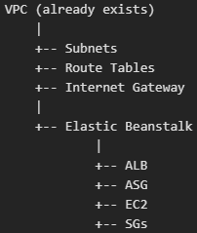
EBeanStalk(PaaS)
Provides – application(code), versioning, envt
Tiers – 2 layers:
- Web envt – manages entire apln
- Worker envt – handles backgound processes and tasks
  - Work is carried out by queueing(SQS) & envt scales based on the sqs
  - Works on tasks from another web tier(received through sqs)
Deployment strategies:
All at once downtime
Rolling deployment(rolling out new version to servers 1 by 1) minimal/no downtime
Canary deployment(routing % of traffic to new server & eventually 100%) new version to a small % of users
Immutable – adding a new group of servers and routing traffic after testing no modification reqd
Blue/Green deployment(create completely new envt & route 50% traffic) instant roll back

Storage
S3 | EBS | EFS | Instance Store
For data like backup, media, files,.. | Attached to 1I*(1AZ)  low-latency workloads like database(self managed DB). | shared file access - across MI(MAZ) | Physically attached Storage.  for temporary data storage – Cache, buffer.

S3
Provisions:
- 2 lvls of access: IAM, Bucket policy
- Bucket[subfolder1/subfolder1a/object], Object level versioning
Std, Std IA,
S3 Intelligent tiering(std -30-> std IA -90-> Archive instant -700-> Deep Archive)
S3 Express 1AZ – fast: 10xS3
Glacier – to store archived files
- Instant(retrieval in ms), Flexible(in mins to hrs), Deep archive(wn 12 hrs)

EBS
- Snapshot, Encryption
  - To move from 1AZ to another AZ, move from unencrypted to encrypted – take snapshot and proceed
SSD | gp2 | Transactional workload | For dev - General workloads |  | $
SSD | gp3 | Transactional workload | For dev - General workloads | IOPS increased indeply | $Default choice✅
SSD | io1 | Transactional workload | For DBs - High IOPS(IOPS incd independantly),  Supports 1 EBS to many EC2(upto 16 instances) ltd to 1 AZ. |  | $$
SSD | io2 | Transactional workload |  | High durability | $$$
Hard Drive | st1 | Large streaming workload (High Throughput reqt) | Big data - memory per request: max- 1MB |  | $
Hard Drive | sc1 | Large streaming workload (High Throughput reqt) | Big data - memory per request: max- 1MB | infrequent access(cold) | Lowest

EFS
Security Groups(on Instance level) - Stateful (only contains allow rules)
NACLs(on subnet level) – stateless

Serverless
AWS Lambda:
Total cost = cost(reqs) + reqs*cost(GB-secs)
Max limits:
Memory(RAM) & Disk(ROM) – 10GB
execution time – 900s
Concurrency – 1k reqs per region; per function concurrency limit should be set to avoid throttling.
Deployment size: 250MB or 50MB(Compressed deployment)

Database

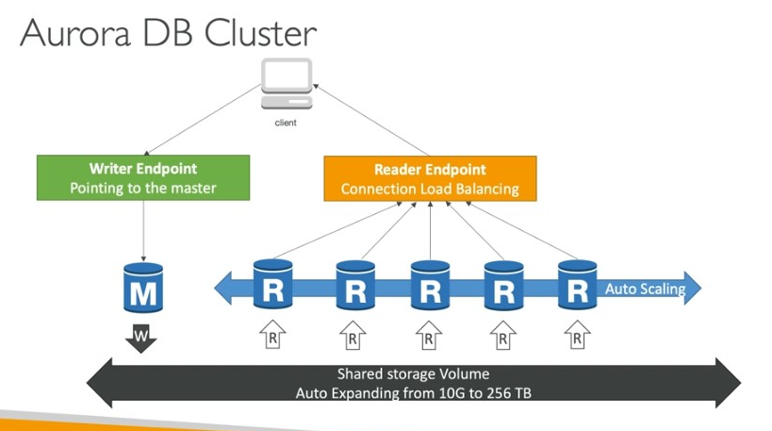
RDS
Replicas – Upon writing data to replica if it’s acknowledged sync replicas o/w async replicas
Replication:
- Taken snapshot & Restored
- Sec DB – Cloned from the primary DB
RDS Proxy – manages connection pooling
Aurora: a cluster fully managed by AWS - HA (across 3AZ) + automatic failover + AS

Elasticache
Redis(Persistant, many DS)
MemCached(non persistant, string based key-value pairs)

DynamoDB(DDB)
- NoSQL DB stores data in Json format
- for DB Schema which evolves horizontally.
- RW Capacity
  - Provisioned mode – RW capacity provided as defined
  - On Demand mode – RW capacity for rare traffic/steep curves.
DAX – Cache kept infront of DDB to avoid read congestion microsecond read latency
- Heavy results from the DDB can be stored using Elasticache
DDB Streams – any update in the DDB can be used as a trigger to perform actions W.H.O. DDB Streams.
DDB Global Tables – DDB deployed in multiple regions kept consistent through MRC(by using DDB Streams underneath (AWS’s responsibility))
DDB TTL – to retain data in DDB for a certain amt of time. Especially manages the data captured during websession
DDB Backups – continuous backups with PITR, on demand backups, Integration with S3,..

Replication
Across multi AZ – Sync
Across multi region, across read replicas – Async
- Exception in DynamoDB

Machine Learning

Data & Analytics
Athena Vs Redshift
Performs querying/analysis directly on s3 | Brings the data to Redshift cluster and the performs analysis
Serverless | Dedicated analytics warehouse

Opensearch: Search and analytics tsool
- Compliments DDB
- Opensearch Dashboard – to visualize analysis
EMR: Elastic Map Reduce: Data processing tool supports Hadoop, Hbase, Presto, apache,..
Quicksight: Serverless BI Service to create interactive dashboard
Access management: users and groups can be created to manage access to dashboards
SPICE engine: performs in-memory computations on pdf,excel,.. to create dashboard
AWS Glue: ETL Tool
Glue Data catalogue, Glue – Job bookmarks, Databrew, Studio, Streaming ETL
AWS Lakeformation: Built on top of AWS Glue to create data lake
- Data lake helps in central security management of all the connected resources/services.
Data Streaming: Kinesis Data Stream Vs MSK/Kafka
best for Real time Data collection | best when data need to be retained(Event DB)
Serverless | Provides serverless MSK

Flink: processes data from Data streams.
Architecture:
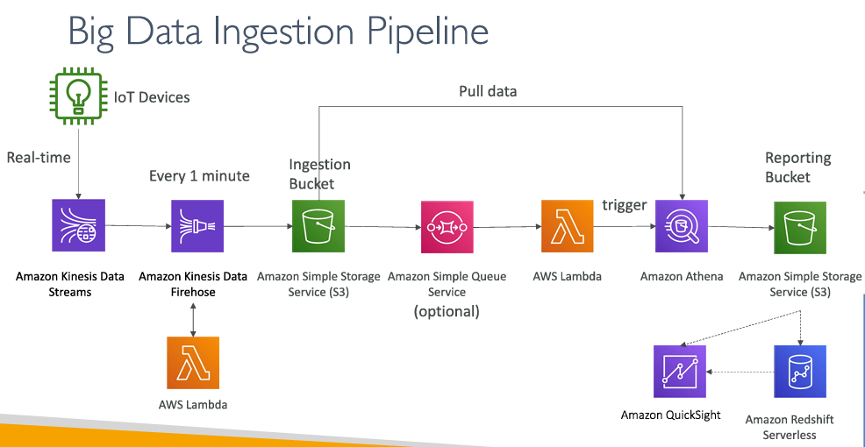

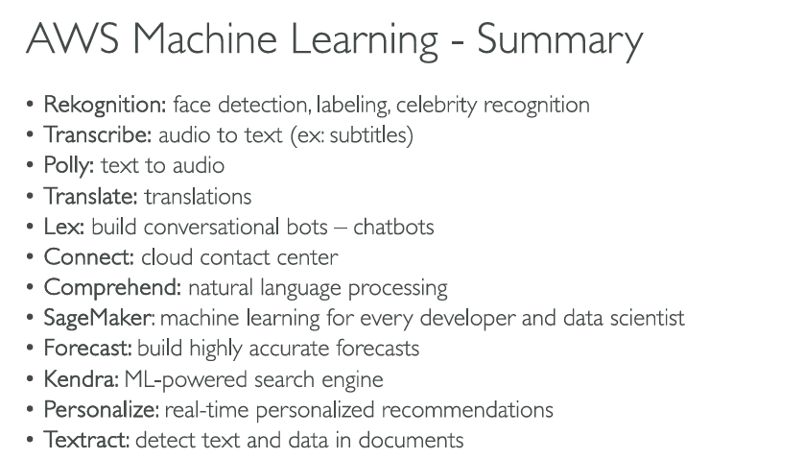

- SageMaker: machine learning for every developer and data scientist to build ML models
- Kendra: ML-powered search engine
- Personalize: to built “real-time personalized recommendations” feature in applications
- Textract: detect text and data in documents and extrac the information

Monitoring & Observability

IAM Advanced

Security & Encryption

Networking – VPC
VPC – Network (in a region)
Subnet: subnetwork of VPC – can be attached to an AZ, specific tier of network
- Route table: routes traffic coming to a subnet.
- Firewall: NACL(stateless)
Gateway- provides routing intelligence: forwards traffic from networkA to other networks
Types of Gateway:
- Internet GW – to connect to internet
- NAT GW – private subnets/resources to connect to internet
- ‘outbound-only’, based on the state memory, NGW allows responses only which are originated from the pvt subnet
- Transit GW – a hub for connections between VPC1, VPC2, VPN, On prem DX, Direct connect to connect among themselves.
  - VPN Cloudhub – a narrowed hub for connections between VPNs only.

Connectivity
Hybrid Connectivity: Connecting On prem network with AWS VPC network
AWS Site – Site VPN: public connectivity with IPSec encryption bw on premises nw to AWS VPC network
AWS Direct connect: dedicated private connectivity(not encd by default) bw on premises nw to AWS VPC network
Direct connect Gateway - Setup Direct connect to many VPCs in different AWS regions
VPC Peering Connection: connects 2 VPCs through AWS network
- 2 VPC networks across different account/diff region connected – to behave the same as 1 VPC

Resource connection: Suppose VPCB wants to access a service from VPCA, instead of peering the entire network VPCA VPCB, we can use endpoint: exposes a specific service from network
VPC Endpoint – to connect AWS Services internally(through internal AWS pvt network rather than internet)
├── Gateway Endpoint: updates route table to reach destination through AWS pvt network Only for: S3, DynamoDB
│
└── Interface Endpoint
├── AWS Services: creates ENI and places it in same subnet
└── PrivateLink Services: to connect with not AWS managed services

Misc VPC
AWS Global Accelerator: improves performance and availability of our application to users
VPC Flow logs – logs networking data flow logs by Accept and reject action status
VPC Mirroring - For deep visibility into network packets
- Use case – content detection, threat detection, troubleshooting

Networking & Components

DNS: Route 53
Route policies – route based on closest region, low latency, weighted distribution
Traffic flow – combines more than one route policy
Domain registrar – buy domain name from 3rd party DNS services(Godaddy - cheaper) and integrate AWS server names to GoDaddy.

Disaster Recovery & Migrations

Architectures II

Automation in AWS with Python + Lambda + serverless
Automation

Knowledge gained from practicing questions

SQS
- SQS triggers ASG based on the metric: “ApproximateNumberOfMessagesVisible”

Miscellaneous

